Contents

1 🔧What’s New 2

2 🚀 Fixed Defects 2

3 🚀 Fixed Issues 2

4 ⭐ Improvements 2

5 🚀 Deployments 3

5.1 Infrastructure 3

5.1.1 File Updates 3

5.1.2 Deployments 3

5.2 CRM 4

5.2.1 Import TASMU_CPM_Core solution manually 4

5.2.2 Deployment 4

5.2.3 CRM Post Deployment Verification 4

5.2.4 CRM Email Template Links Update 4

5.3 CDN 5

5.4 Web Apps 5

5.5 Platform APIs 5

5.6 APIM 5

6 💻 Reviewers 6

7 Appendix 7

7.1 Post Deployment Verification 7

7.2 Running Pipeline from Tags 7

Release Notes

# 🔧What’s New

New user stories delivered: **None**

# 🚀 Fixed Defects

The following bugs reported in SIT are addressed in the current interim build –

| **ID** | **Title** | **Severity** | **Priority** |
| --- | --- | --- | --- |
| [35769](https://dev.azure.com/TASMUCP/TASMU%20MSI/_workitems/edit/35769) | FN- Portal - By Selecting any Category from the list, values from all the other mentioned categories become 0. | 3 - Medium | 2 |
| [35961](https://dev.azure.com/TASMUCP/TASMU%20MSI/_workitems/edit/35961) | B2C - Order Subscription - Review and Subscribe: A wrong text for adding another card | 3 - Medium | 2 |
| [35987](https://dev.azure.com/TASMUCP/TASMU%20MSI/_workitems/edit/35987) | NF-B2B Marketplace-My Published Services page is not matching with CEX | 3 - Medium | 2 |
| [36004](https://dev.azure.com/TASMUCP/TASMU%20MSI/_workitems/edit/36004) | FN-B2B- Error is shown to new user on Billing Address screen while placing the order | 3 - Medium | 2 |
| [36029](https://dev.azure.com/TASMUCP/TASMU%20MSI/_workitems/edit/36029) | B2B - 404 Error seen in a case | 3 - Medium | 2 |
| [36045](https://dev.azure.com/TASMUCP/TASMU%20MSI/_workitems/edit/36045) | KB Article Video link not displaying in Portal. | 3 - Medium | 2 |

# 🚀 Fixed Issues

The following issues reported are addressed in the current build –

| **ID** | **Title** | **Priority** |
| --- | --- | --- |
| [36003](https://dev.azure.com/TASMUCP/TASMU%20MSI/_workitems/edit/36003) | Add new value to Frequency (Portal) | 2 |

# ⭐ Improvements

Minification of CDN content (HTML, CSS) to improve performance of Azure AD B2C (Login and registration pages).

**CRM:**  
Email template styles updated.

# 🚀 Deployments

## Infrastructure

Pull Request – [Pull request 6959: Merge TASMU CP into TASMU MSI - 20 May 2021 - Repos (azure.com)](https://dev.azure.com/TASMUCP/TASMU%20MSI/_git/infra/pullrequest/6959)

### File Updates

1. Add/Update the following parameter files (refer UAT files) -

|  |  |  |  |
| --- | --- | --- | --- |
| **Module** | **Parameter File** | **Action** | **Properties** |
| StorageAccount | st<sub>appsapimt<env>we01  st<sub>appsdiag<env>we01  st<sub>appsint<env>we01  st<sub>appsstr<env>we01  st<sub>shrddiag<env>we01  st<sub>shrd<env>we01 | Update | allowBlobPublicAccess,  minimumTlsVersion,  and diagnostic settings |
| BitnamiCkan | ckan-<sub>-apps-<env>-we-01 | Update | allowBlobPublicAccess,  vmImageReferenceVersion,  storageMinimumTlsVersion |
| RedisCache | redis-<sub>-apps-str-<env>-we-01 | Update | minimumTlsVersion |
| ContentDeliveryNetworkEndpoint | <env>-cdntasmu | Update | deliveryPolicy,  queryStringCachingBehavior |

### Deployments

1. Run the following pipelines -
   1. CD-rg-<sub>-shrd-mon-<env>-we-01-Master-Release
   2. CD-rg-<sub>-shrd-<env>-we-01-Master-Release
   3. CD-rg-<sub>-apps-mon-<env>-we-01-Master-Release
   4. CD-rg-<sub>-apps-str-<env>-we-01-Master-Release
   5. CD-rg-<sub>-apps-int-<env>-we-01-Master-Release
   6. CD-rg-<sub>-apps-ckan-<env>-we-01-Master-Release
   7. CD-AppConfigurations-Master-Release

## CRM

### Import TASMU_CPM_Core solution manually

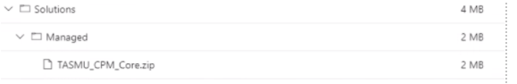

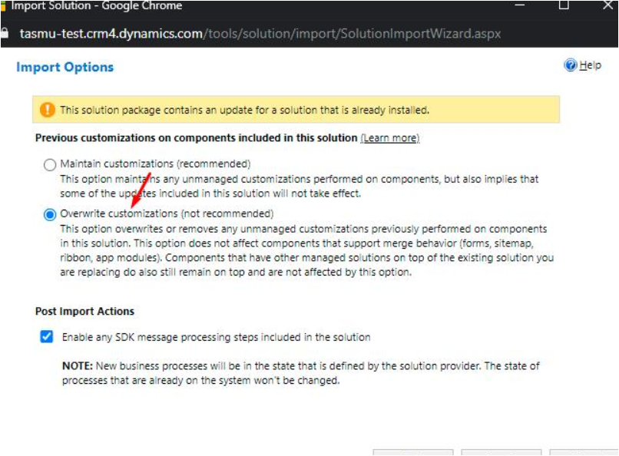

### Deployment

|  |  |
| --- | --- |
| **Build Id** | **Pipeline Name** |
| 43271 | [CD-CrmPlatform-Release](https://dev.azure.com/TASMUCP/TASMU%20Central%20Platform/_build/results?buildId=43271&view=results) |

### CRM Post Deployment Verification

[Verify workflows are activated from deployment guide](https://dev.azure.com/TASMUCP/TASMU%20Central%20Platform/_wiki/wikis/TASMU-Central-Platform.wiki/137/Dynamics-365-Deployment-Guide) (Refer 5.16 section)

### CRM Email Template Links Update

[Link to be changed in Email templates in CRM and Images needs to be uploaded for Prod](https://dev.azure.com/TASMUCP/TASMU%20Central%20Platform/_wiki/wikis/TASMU-Central-Platform.wiki/137/Dynamics-365-Deployment-Guide?anchor=5.17-email-templates-in-crm-and-images-needs-to-be-uploaded-for-prod) (Refer 5.17 section)

## CDN

|  |  |
| --- | --- |
| **Tag** | **Pipeline Name** |
| SIT_CDN_20May2021 | [CD-CDNContainer-Prd-Release](https://dev.azure.com/TASMUCP/TASMU%20Central%20Platform/_build?definitionId=1019) |

## Web Apps

|  |  |
| --- | --- |
| **Tag** | **Pipeline Name** |
| SIT_Web_20May2021 | [CD-WebApps-Prd-Release](https://dev.azure.com/TASMUCP/TASMU%20Central%20Platform/_build?definitionId=1020) |

## Platform APIs

|  |  |
| --- | --- |
| **Tag** | **Pipeline Name** |
| SIT_API_20May2021 | [CD-PlatformAPIs-Prd-Release](https://dev.azure.com/TASMUCP/TASMU%20Central%20Platform/_build?definitionId=1021) |

## APIM

|  |  |  |
| --- | --- | --- |
| **Tag** | **APIs** | **Pipeline Name** |
| SIT_APIM_20May2021 | NotificationApi | [CI-APIMConfig-CentralPlatformCore-Master-Prd-Build](https://dev.azure.com/TASMUCP/TASMU%20Central%20Platform/_build?definitionId=1150) |
| SIT_APIM_20May2021 | NotificationApi | [CD-APIMConfig-pre-Release](https://dev.azure.com/TASMUCP/TASMU%20Central%20Platform/_build?definitionId=962) |

# 💻 Reviewers

|  |  |
| --- | --- |
| Prepared By | Manvir Kaur, Sumit Gupta |
| Company name | Microsoft |
| Reviewed by | Ravi Sankar Pillutla, Anil Erkek, Subhajit Chatterjee, Gareeb Navas T M, Mecit Atmaca |
| Approved by | Ashwani Sharma |

# Appendix

## Post Deployment Verification

1. Function Apps Running
2. <https://func-cpp-apps-ckan-pre-we-01.azurewebsites.net/>
3. <https://func-cpp-apps-qnasync-pre-we-01.azurewebsites.net/>
4. <https://func-cpp-apps-luistra-pre-we-01.azurewebsites.net/>
5. <https://func-cpp-apps-intbpa-pre-we-01.azurewebsites.net/>
6. <https://func-cpp-apps-intntf-pre-we-01.azurewebsites.net/>
7. <https://func-cpp-apps-pt-pre-we-01.azurewebsites.net/>
8. Marketplace Portal - <https://marketplace.pre.sqcp.qa/en/>
9. Bot – Chat with bot on marketplace
10. My Tasmu Portal - <https://mytasmu.pre.sqcp.qa/en/>
11. Account Portal - <https://account.pre.sqcp.qa/en/>
12. Admin Portal Portal - [https://cpadmin.pre.sqcp.qa](https://cpadmin.pre.sqcp.qa/)  (Login screen should come)
13. API Config access - <https://api.pre.sqcp.qa/config/api/feature>
14. Open Data Portal - <https://opendata.pre.sqcp.qa/>

## Running Pipeline from Tags

